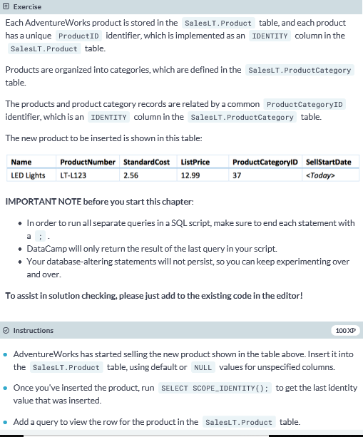

**-- Finish the INSERT statement**

**INSERT INTO SalesLT.Product (Name, ProductNumber, StandardCost, ListPrice, ProductCategoryID, SellStartDate)**

**VALUES**

**('LED Lights', 'LT-L123', 2.56, 12.99, 37, GETDATE());**

**-- Get last identity value that was inserted**

**SELECT SCOPE_IDENTITY();**

**-- Finish the SELECT statement**

**Select * FROM SalesLT.Product**

**WHERE ProductID = SCOPE_IDENTITY();**

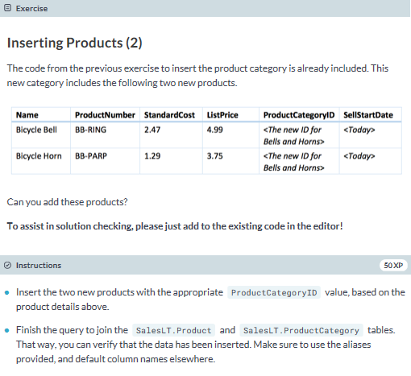

**-- Insert product category**

**INSERT INTO SalesLT.ProductCategory (ParentProductCategoryID, Name)**

**VALUES**

**(4, 'Bells and Horns');**

**-- Insert 2 products**

**INSERT INTO SalesLT.Product (Name, ProductNumber, StandardCost, ListPrice, ProductCategoryID, SellStartDate)**

**VALUES**

**('Bicycle Bell', 'BB-RING', 2.47, 4.99, IDENT_CURRENT('SalesLT.ProductCategory'), GETDATE()),**

**('Bicycle Horn', 'BB-PARP', 1.29, 3.75, IDENT_CURRENT('SalesLT.ProductCategory'), GETDATE());**

**-- Check if products are properly inserted**

**SELECT c.Name As Category, p.Name AS Product**

**FROM SalesLT.Product AS p**

**JOIN SalesLT.ProductCategory as c ON p.ProductCategoryID = c.ProductCategoryID**

**WHERE p.ProductCategoryID = IDENT_CURRENT('SalesLT.ProductCategory');**

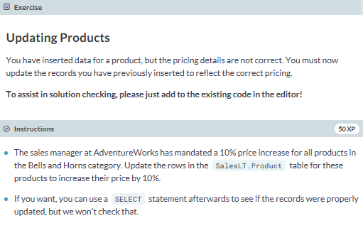

**-- Update the SalesLT.Product table**

**UPDATE SalesLT.Product**

**SET ListPrice = ListPrice * 1.1**

**WHERE ProductCategoryID =**

**(SELECT ProductCategoryID FROM SalesLT.ProductCategory WHERE Name = 'Bells and Horns');**

**-- You can add a SELECT statement to check the update**

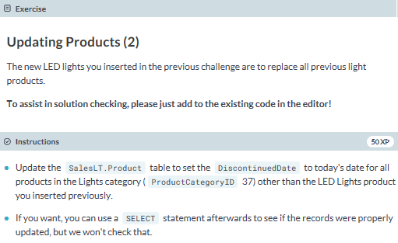

**-- Finish the UPDATE query**

**UPDATE SalesLT.Product**

**SET DiscontinuedDate = GETDATE()**

**WHERE ProductCategoryID = 37 AND ProductNumber <> 'LT-L123';**

**-- You can use SELECT to check the update**

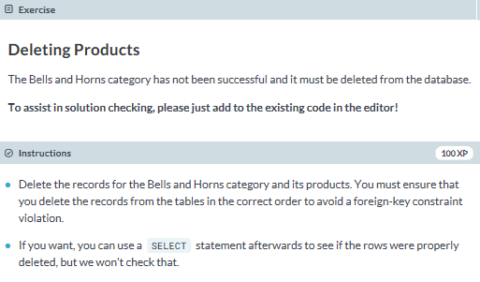

**-- Delete records from the SalesLT.Product table**

**DELETE FROM SalesLT.Product**

**WHERE ProductCategoryID =**

**(SELECT ProductCategoryID FROM SalesLT.ProductCategory WHERE Name = 'Bells and Horns');**

**-- Delete records from the SalesLT.ProductCategory table**

**DELETE FROM SalesLT.ProductCategory**

**WHERE ProductCategoryID =**

**(SELECT ProductCategoryID FROM SalesLT.ProductCategory WHERE Name = 'Bells and Horns');**

**-- You can use SELECT to check the deletions**